Measurements Needed for Coats
Henry Cooke, Tailoring Workshop
New Brunswick Museum, 26-27 October 2019

Name:

Address:

Telephone:

Email:

# Kit: Kit’s name :

Colour: Fabric:

How to take the Measures
Have someone else take your measures in inch, if possible. Because of physiological changes of your body during movement, self-inflicted measures often have errors, sometimes to the point of being impossible to take.
If possible, wear the clothes that you will be wearing under the coat or jacket, or wear clothes of comparable thickness when you have your measurements taken. In this way, the coat will fit smoothly without binding.
When taking measures the tape should be held easily and naturally, neither held slack nor drawn tight. When taking measures of the circumference of the arm, the arm should be flexed to get the maximum dimension and avoid constraint.

Measures Needed - Have the following measurements taken in inches, writing each one down as taken.

_____in Neck over shirt and stock or neck-cloth

_____in Across back of shoulders, from shoulder joint to shoulder joint

_____in Length of front, from top of shoulder to hip bone

_____in Length of front, from top of shoulder to top of knee

_____in Circumference of chest, measured just under the armpits

_____in Circumference of waist at the top of the hip bone (just below navel)

_____in Length of arm from joint of shoulder to wrist bone with the arm hanging down

_____in Length of arm from point of shoulder to elbow with arm bent

_____in Circumference of bicep of arm when flexed

_____in Circumference of forearm when flexed

_____in Measure from front of armpit, across breast to front of opposite armpit, then divide
in half to get the distance from the front of arm to the center front of the coat.

(continue on the next page)

_____in Scye depth – measured from the top of the shoulder to the bottom of the armpit
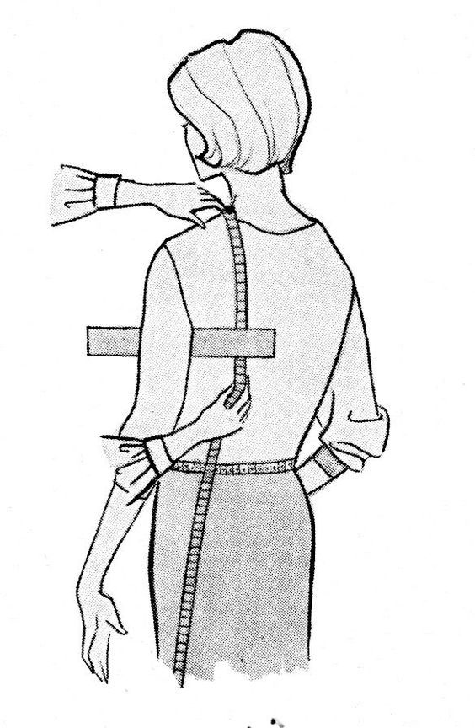

Questions? Contact, Henry Cooke, at 781-963-9645, or hcooke4@verizon.net

